

**Internship project**

**Report on**

# Vehicle Speed Measurment Using IBM Machine Learning service

SUBMITTED BY:

s KRUTHIKA S R 4BD18CS034

MEGHANA M 4BD18CS046

MADHURA S R 4BD18CS039

NEHA N 4BD18CS053



DEPARTMENT OF COMPUTER SCIENCE AND ENGINEERING

# BAPUJI INSTITUTE OF ENGINEERING AND TECHNOLOGY DAVANGERE

ACADEMIC YEAR: 2021-2022

## CONTENTS

**CHAPTERS PAGE NO’S**

1. **INTRODUCTION 01** 
   1. Overview 01
   2. Purpose 01
2. **LITERATURE SURVEY 02** 
   1. Existing Problem 02
   2. Proposed Solution 02
3. **THEORETICAL ANALYSIS 03** 
   1. Block Diagram 03
   2. Hardware and Software Design 04
4. **EXPERIMENTAL INVESTIGATIONS** **05**
5. **FLOWCHART 06**
6. **RESULT 07 - 10**
7. **ADVANTAGES AND DISADVANTAGES 11**
8. **APPLICATIONS 12**
9. **CONCLUSION AND FUTURE SCOPE 13**
10. **BIBILOGRAPHY 14**

# INTRODUCTION

## 1.1 OVERVIEW

Rash driving is the cause of many road accidents all over the world. A total of 4,73,084 traffic accidents were reported during the last decade in India. The traffic population has increased considerably in India as there is no means to control or monitor the speed of vehicles running on roads. To overcome this problem and decrease the death rate due to accidents, the introduction of new and innovative speed enforcement technology is necessary.

The project is to identify overspeed vehicles. After acquisition of series of images from the video, Vehicles are detected using Haar Cascade Classifier. The model for the classifier is trained using lots of positive and negative images to make an XML file. This is followed by tracking down the vehicles and estimating their speeds.

## 1.2 PURPOSE

This project aims at designing a device that analyses the real-time video of vehicles passing on highways to estimate the speed of the vehicles passed and maintain a log of the speed of vehicles tracked at a particular timestamp.

The main objective of this project is to identify overspeed vehicles. After acquisition of series of images from the video, Vehicles are detected using Haar Cascade Classifier. The model for the classifier is trained using lots of positive and negative images to make an XML file. This is followed by tracking down the vehicles and estimating their speeds. the calculated speed of the trucks is fed into an excel sheet

# 

# LITERATURE AND SURVEY

## 2.1 EXISTING SYSTEM

Automatic detecting vehicles in video surveillance data is a very challenging problem in computer vision with important practical applications, such as traffic analysis and security. Vehicle detection and counting is important in computing traffic congestion on highways or roads.

## 2.2 PROPOSED SYSTEM

1. Vehicle Detection
   * We are using Haarcascade classifier to identify vehicles.
2. Vehicle Tracking - ( assigning IDs to vehicles )
   * We have used corelation tracker from dlib library.
3. Speed Calculation
   * We are calculating the distance moved by the tracked vehicle in a second, in terms of pixels, so we need pixel per meter to calculate the distance travelled in meters.
   * With distance travelled per second in meters, we will get the speed of the vehicle.

3 THEORITICAL ANALYSIS

3.1 Block diagram Diagrammatic overview of the project.

3.2 Hardware / Software designing

# THEORETICAL ANALYSIS

## 3.1 BLOCK DIAGRAM

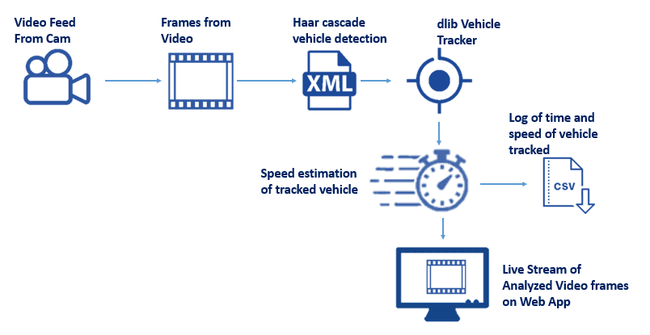

# 3.2 HARDWARE AND SOFTWARE DESIGNING

**HARDWARE DESIGNING:**

The hardware required for the development of this project is:

* Processor : Intel® CoreTM i5-9300H
* Processor speed : 2.4GHz
* RAM Size : 8 GB DDR
* System Type : X64-based processor

**SOFTWARE DESIGNING:**

The software required for the development of this project is:

* Desktop GUI : Anaconda Navigator
* Operating System : Windows 10(and other higher version)
* Front end : HTML,CSS
* Programming Language : PYTHON
* Cloud Computing Service : IBM Cloud Services

# 

# EXPERIMENTAL INVESTIGATIONS

we have taken the video frame and calculated the width of the road in pixels digitally. Now, we have the width of the road in metres from the real world and in pixels from our video frame. To map the distances between these two worlds, we have calculated pixels per metre by dividing distance of road in pixels to metres.

# FLOWCHART

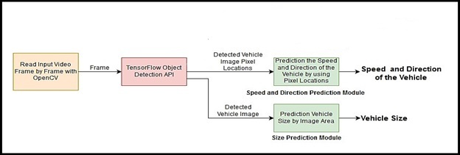

## RESULT

**Following are the result of this project**

* Read all the necessary libraries
* Capture the video it will read the frame . With the help of correlation tracker it tracks the vehicle first then it measures the speed
* Assign a new ID to the vehicle tracked.
* Find the locations of vehicles tracked.
* Calculated pixels per meter by dividing the distance of the road in pixels to meters.
* Calculate the speed.
* Display the streaming video Web Application.
* Save the speed of the vehicle and timestamp wt which vehicle is tracked into a CSV file.

**Source Code**

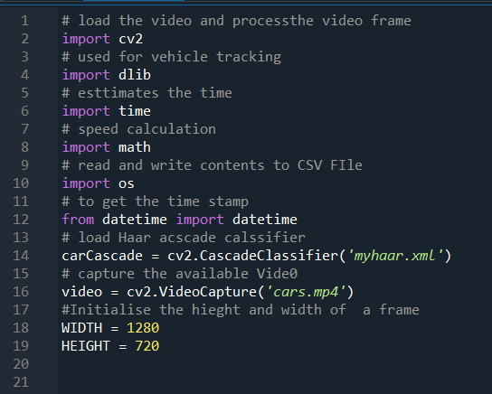

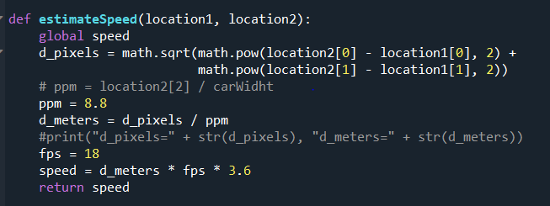

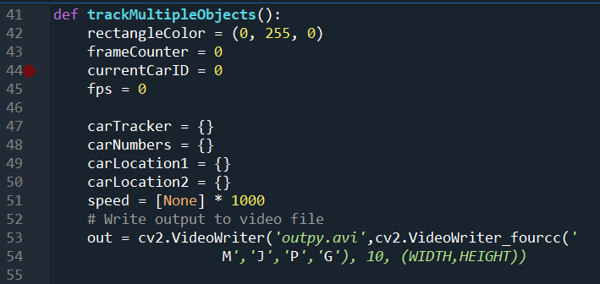

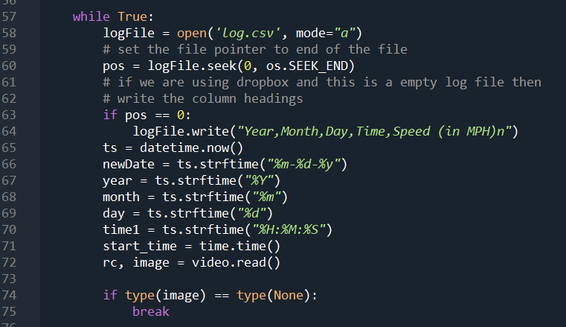

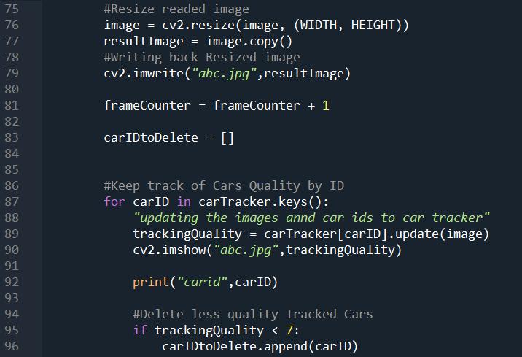

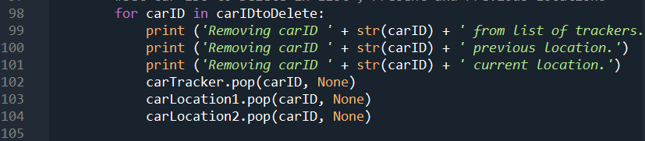

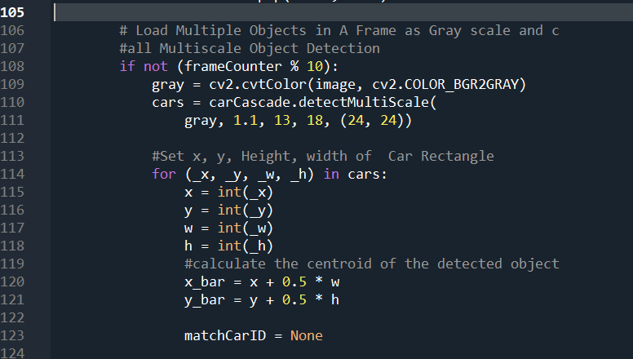

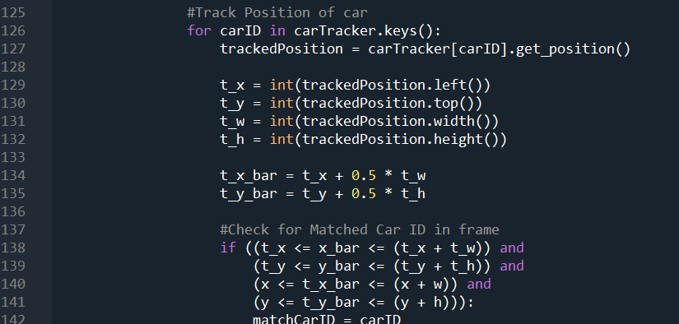

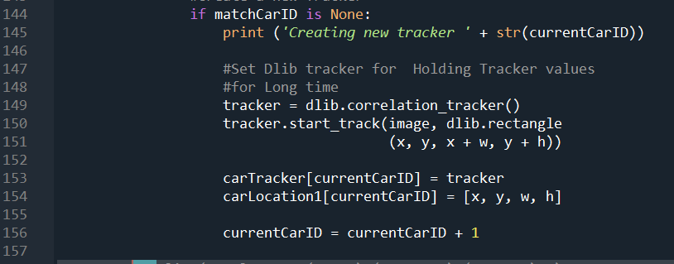

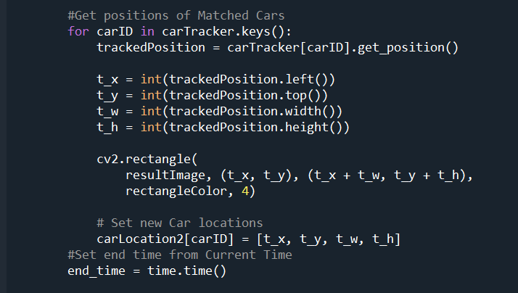

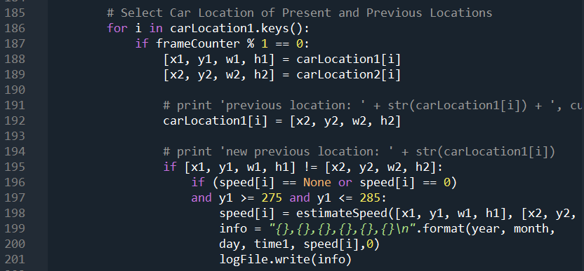

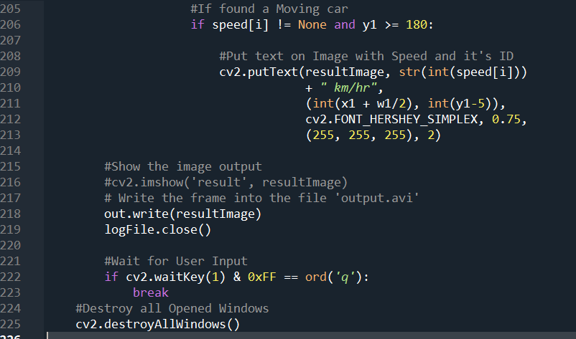

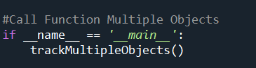

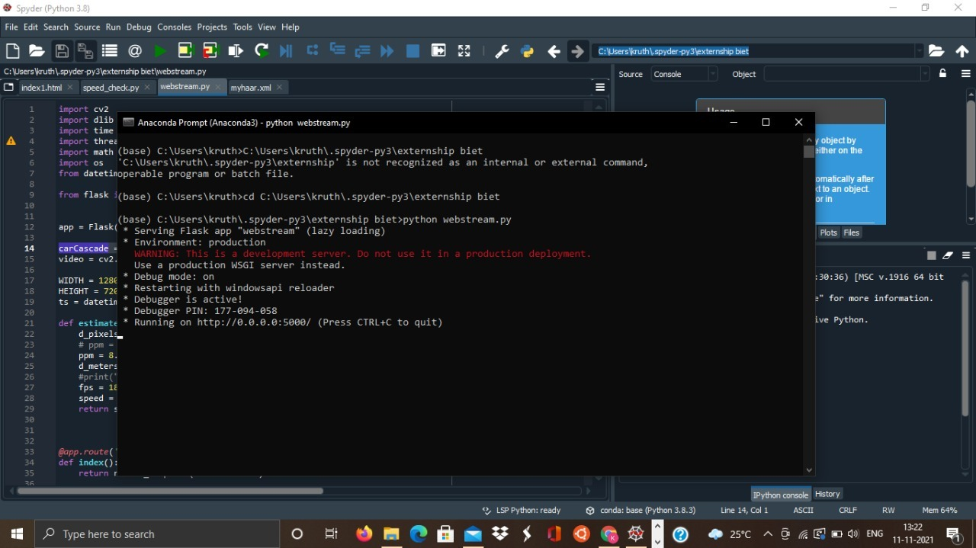

**Fig -** Promt usage page

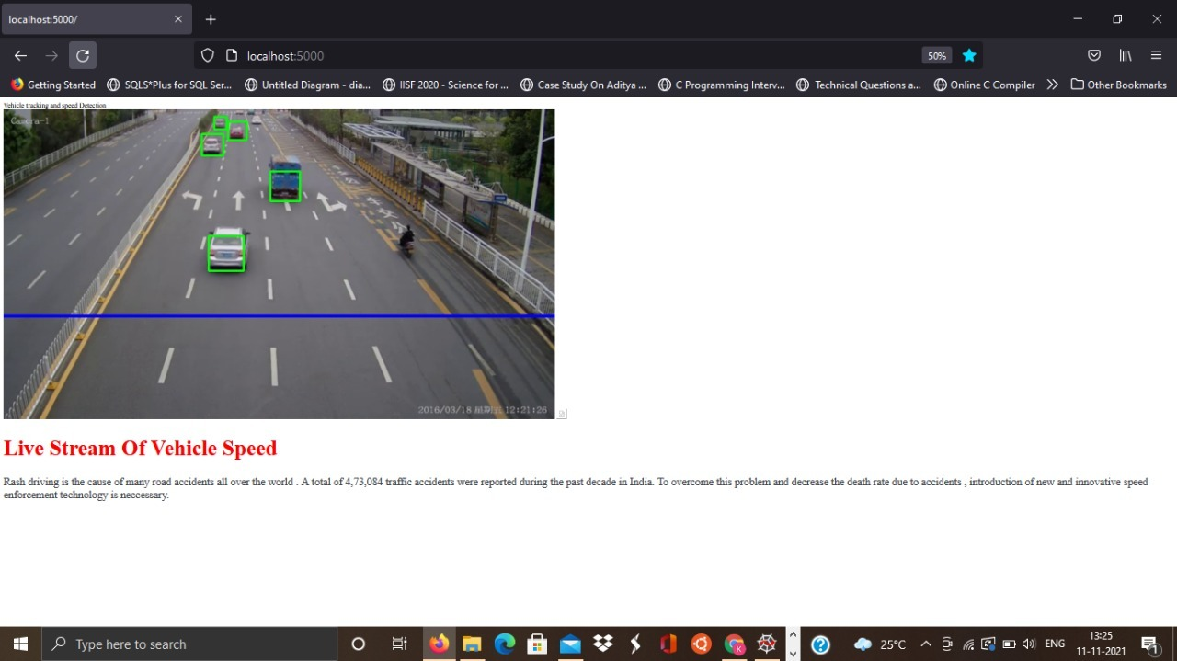

**Fig –** Output page

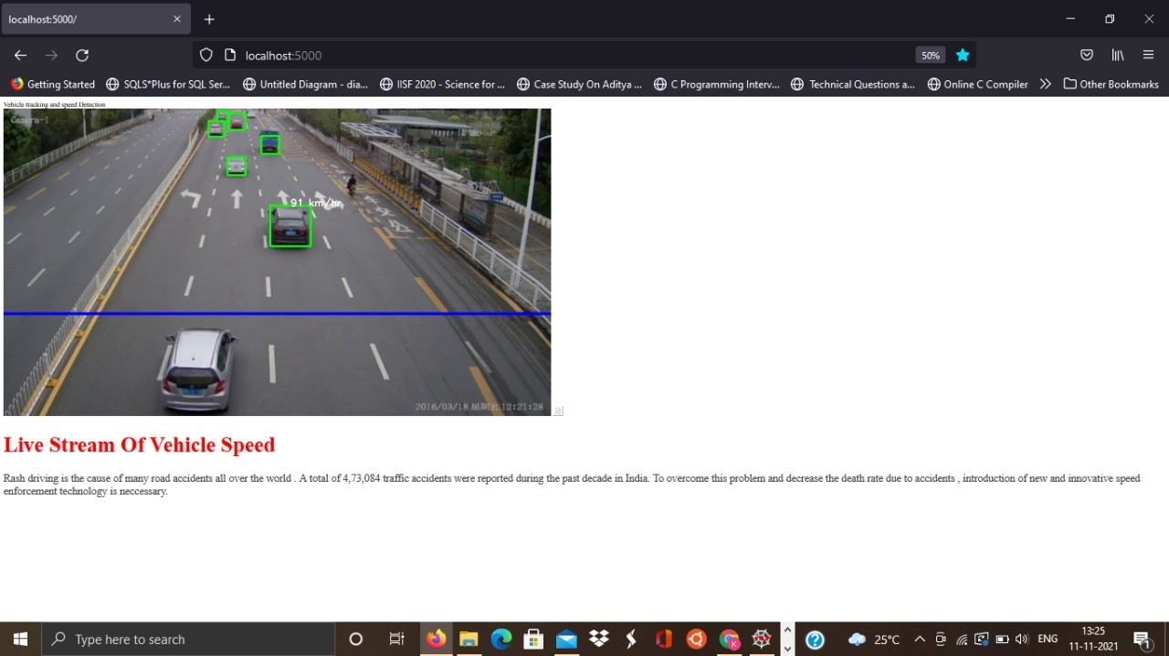

**Fig –** Final output obtain

**CHAPTER 7**

## ADVANTAGES AND DISADVANTAGES

### ADVANTAGES

* It helps to monitor the vehicle speed hence will reduce the work the traffic police .
* This technique can be used in gaming industry , sports club etc.

### DISADVANTAGES

* The license plate, occasionally, are covered with dust or are veiled by a rod in the front or are not even there, thereby not letting the detection possible.
* A good resolution camera ought to be used for predicting non-erroneous license plate characters. Neural Enhance – Super Resolution of images (Deep Learning) can also be used, instead. However it increases the processing time.

* Old trucks cannot be identified because the machine is trained using only new models of trucks.

.

**CHAPTER 8**

**APPLICATIONS**

* Online video gaming industry
* Overspeed control
* Sports industry – Horse race, Swimming, Car race

**CHAPTER 9**

## CONCLUSION AND FUTURE SCOPE

### CONCLUSION

This paper proposes a video-based vehicle speed measurement system for traffic applications as a part of intelligent transportation systems. The suggested approach works on the output videos of road cameras and produces detected vehicle images, their estimated speed, and detection time. This method is based on motion detection algorithms and contains three sequential components, viz. vehicle detection, tracking, and speed measurement. In the detection step, Mixture-of-Gaussian background subtraction method and morphology transforms are utilized. Detected objects are then tracked using blob tracking algorithm and their displacement in comparison with the previous frame. The average displacements inside the region of interest were used for speed measurement. In addition, the proposed method is not dependent on the visual features of vehicles and detects them inside a predefined region by analyzing their motion parameters. To analyze the method, it was tested on two different real datasets and the final results validated the accuracy of more than 94% for vehicle detection and 94.8% for speed measurement.

### FUTURE SCOPE

Estimate the values manually for the current road to calculate pixels per metre(ppm). Therefore, the value will vary from road to road and have to be adjusted to be used on any other video.

If I talk about the part how we estimated ppm, we need to know the actual width in metres of the road

**CHAPTER 10**

# BIBILOGRAPHY

References of previous works or websites visited/books referred for analysis about the project, solution previous findings etc.

[**http://marsyas.info/downloads/datasets.html**](http://marsyas.info/downloads/datasets.html)

[**https://smartinternz.com/Student/dashboard**](https://smartinternz.com/Student/dashboard)